WEEK 3 MANDATORY HANDS-ON QUESTIONS

EXERCISE 1: UNDERSTANDING ORM WITH A RETAIL INVENTORY SYSTEM

Explain how ORM maps C# classes to database tables.

ORM (Object-Relational Mapping) in C# maps classes to database tables by treating each class as a table and each property as a column. Frameworks like Entity Framework handle this mapping automatically, allowing developers to work with objects instead of writing SQL queries directly. The ORM translates C# LINQ queries into SQL, manages relationships like one-to-many or many-to-many through navigation properties, and keeps the object model in sync with the underlying database schema.

**Benefits**:

* **Productivity**: Write less boilerplate code.
* **Maintainability**: Cleaner codebase and reusable models.
* **Abstraction**: Avoid writing raw SQL; use LINQ instead.

## **EF Core vs EF Framework**

|  |  |  |
| --- | --- | --- |
| **Feature** | **EF Core** | **EF Framework (EF6)** |
| Platform Support | Cross-platform (Windows/Linux/Mac) | Windows-only |
| Performance | Lightweight & fast | Slower for modern apps |
| Features | LINQ, Async, Compiled Queries, JSON mapping | Mature but older patterns |
| Target Apps | .NET 6/7/8 apps, Blazor, ASP.NET Core | Legacy .NET Framework apps |

## **EF Core 8.0 Features**

* **JSON column mapping**: Store and query JSON data directly.
* **Compiled models**: Faster startup with precompiled metadata.
* **Interceptors**: Hook into DB operations (e.g., for logging).
* **Bulk operations**: More efficient inserts/updates.

EXERCISE 2: SETTING UP THE DATABASE CONTEXT FOR A RETAIL STORE

CREATING MODELS:

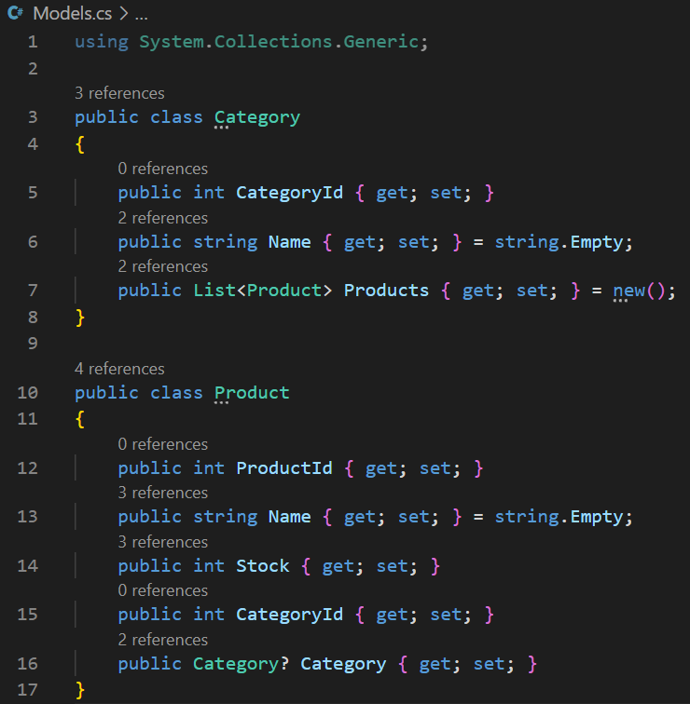

CREATING INVENTORYCONTEXT

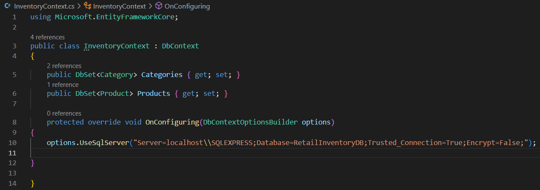

EXERCISE 3: CREATE AND APPLY MIGRATIONS

Step 1: INSTALLING EF Core CLI



STEP 2: CREATING INITIAL MIGRATION

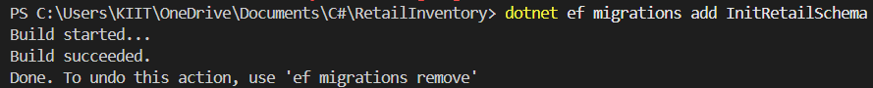

STEP 3: APPLY MIGRATION TO CREATE DATABASE

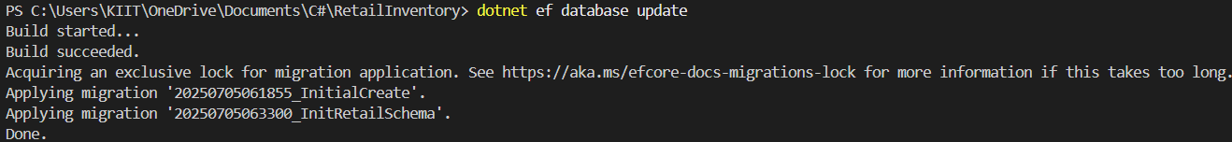

EXERCISE 4: INSERTING INITIAL DATA INTO THE DATABASE

INSERTING DATA INTO PROGRAM.CS

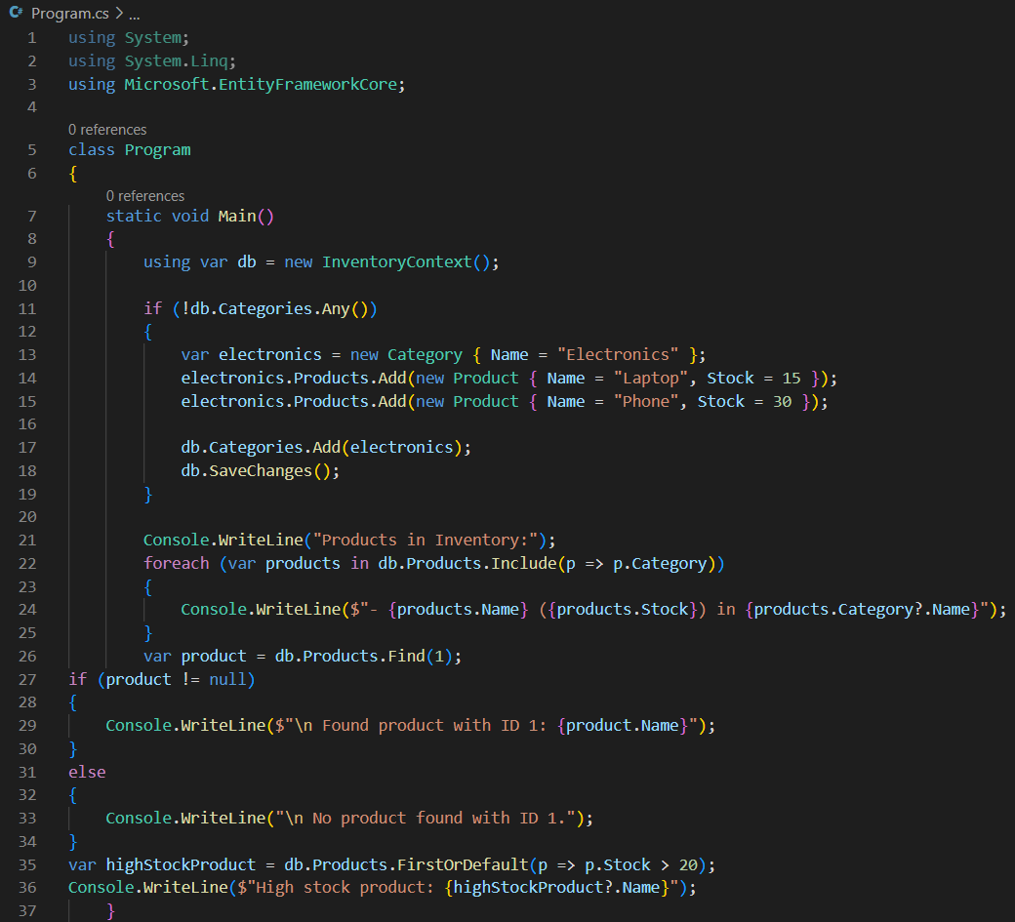

EXERCISE 5: RETRIEVING DATA FROM THE DATABASE

STEP 1: RETRIEVE ALL PRODUCTS

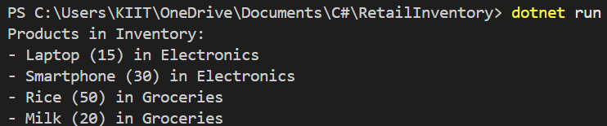

STEP 2: FIND BY ID

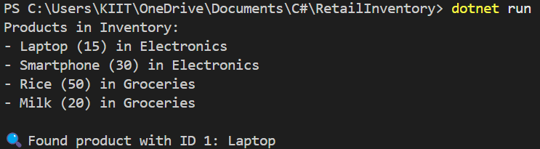

STEP 3: FIRSTORDEFAULT WITH CONDITION

